**1. INTRODUCTION**

**1.1. PURPOSE:**

In this existing system most of records are maintained on paper. It becomes very in convenient to modify the data. In the existing system, here easy possibility that the same data in different registers may have values which means the entries of the same data do not match. This in consistent state does not supply the concrete information which poses a problem in the case information related to particular search record [6].

**1.2. SCOPE:**

A medical shop uses a personal computer to maintain the inventory of medicines that are being sold at the shop. The list includes details such as name, company, quantity, expiry date, stock price, etc. whenever a customer wants a medicine the shop keepers inputs the product and company of the book and the system replies whether it is in the list or not. If it is not an appropriate messages displayed.

**1.3. EXISTING SYSTEM:**

* The existing system will provide only medicine information.
* This app produces all details of different medicines.
* But searching those medicines take a lot of time.
* This will not provide this type of facility to consumer.

**1.4. PROPOSED SYSTEM:**

* Online medical store management system provides some more facility like representatives.
* They can save their time by using this website; the medicines are available according to deceases.

**2. REVIEW OF LITERATURE**

**2.1. OVERVIEW:**

This system is used to maintain the information about the medicines. The users can add medicines names into the system by the administrator. Online Medical Store is an online web application where the customer can purchase medicine online. Through a web browser the customers can search for a medicine by its name or company name, later can add to the shopping cart and finally purchase the medicines [1].

**2.2. MODULES:**

This application consists of two modules. They are

* Administrator
* User

Administrator module:

In this module admin can manages all the information like rejecting / approving Manages properties, customers and sellers. The main functions of administrator are

* + - Login
    - Insert Medicine
    - Delete Medicine
    - Update Medicine
    - Create Users
    - Change Password
    - Logout

User module:

In this module, purchase the medicines.The users can login into the system and perform some functionalities. Those are

* + - Login
    - Add to Cart
    - View Cart
    - Billing
    - Logout

**3. SOFTWARE REQUIREMENT SPECIFICATION**

|  |  |  |
| --- | --- | --- |
| **S.NO** | **System Feature ID** | **Title** |
| 1. | OMSM-SRS01 | Login |
| 2. | OMSM-SRS02 | Insert Medicine |
| 3. | OMSM-SRS03 | Delete Medicine |
| 4. | OMSM-SRS04 | Update Medicine |
| 5. | OMSM-SRS05 | Create Users |
| 6. | OMSM-SRS06 | Change Passwords |
| 7. | OBSMS-SRS07 | Add to Cart |
| 8. | OMSM-SRS08 | View Cart |
| 9. | OMSM-SRS09 | Bills |
| 10. | OMSM-SRS10 | Logout |

**Fig: 3. Main table**

|  |  |
| --- | --- |
| **System Feature ID** | **OMSM-SRS01** |
| Title | Login |
| Actor | Admin, User |
| Description | This function is used for the purpose of login |
| Input | Username, password |
| Business logic | 1.connect to database  2.verify the user name & password |
| Conditions to be checked on data | Validate the user id/password |
| Output | Login into system |

**Fig: 3.1. Login table**

|  |  |
| --- | --- |
| **System Feature ID** | **OMSM-SRS02** |
| Title | Insert Medicine |
| Actor | Admin |
| Description | This function is used for adding medicine categories |
| Input | Medicine Categories |
| Business logic | 1.connect to database  2.Medicine added into database |
| Conditions to be checked on data | NA |
| Output | Medicine added successfully |

**Fig: 3.1. Login table**

**Fig: 3.2. Medicine added table**

|  |  |
| --- | --- |
| **System Feature ID** | **OMSM-SRS03** |
| Title | Delete Medicine |
| Actor | Admin |
| Description | This function is used for the purpose of delete medicine |
| Input | Click on stream |
| Business logic | 1.connect to database  2.stream deleted into database |
| Conditions to be checked on data | NA |
| Output | Deleted Medicine successfully |

**Fig: 3.3. Deleted Medicine table**

|  |  |
| --- | --- |
| **System Feature ID** | **OMSM-SRS04** |
| Title | Update Medicine |
| Actor | Admin |
| Description | This function is used to update medicine |
| Input | Click on update medicine |
| Business logic | 1.connect to database  2.medicine update into database |
| Conditions to be checked on data | NA |
| Output | Update Medicine type successfully |

**Fig: 3.4.** **Update Medicine type table**

|  |  |
| --- | --- |
| **System Feature ID** | **OMSM-SRS05** |
| Title | Create Users |
| Actor | Admin |
| Description | This function is used to Create Users |
| Input | Click on Create Users |
| Business logic | 1.connect database  2.create users into database |
| Conditions to be checked on data | NA |
| Output | Created Users successfully |

**Fig: 3.5. Created Users table**

|  |  |
| --- | --- |
| **System Feature ID** | **OMSM-SRS06** |
| Title | Change Passwords |
| Actor | Admin |
| Description | This function is used to change passwords |
| Input | Click on Change Passwords |
| Business logic | 1.connect database  2.password changed into database |
| Conditions to be checked on data | NA |
| Output | Change Passwords successfully |

**Fig: 3.6. Change Passwords table**

|  |  |
| --- | --- |
| **System Feature ID** | **OMSM-SRS07** |
| Title | Add to Cart |
| Actor | User |
| Description | This function is used for medicines add to cart |
| Input | Click on add to cart |
| Business logic | 1.connect to database  2. add to cart on medicines on the database |
| Conditions to be checked on data | NA |
| Output | Add to cart medicines added successfully |

**Fig: 3.11. Add to** **Cart table**

|  |  |
| --- | --- |
| **System Feature ID** | **OMSM-SRS08** |
| Title | View Cart |
| Actor | User |
| Description | This function is used to View Cart for add cart medicines |
| Input | Click on view cart |
| Business logic | 1.connect to database  2.view cart to database |
| Conditions to be checked on data | NA |
| Output | Representatives added successfully |

**Fig: 3.12. Representatives table**

|  |  |
| --- | --- |
| **System Feature ID** | **OMSM-SRS09** |
| Title | Bills |
| Actor | User |
| Description | This function is used to parchase medicinesbills |
| Input | Click on bills |
| Business logic | It retrieves the view cart medicines |
| Conditions to be checked on data | NA |
| Output | Bills Displayed successfully |

**Fig: 3.13. Bills table**

**4. SYSTEM DESIGN**

USE CASE DIAGRAMS

Admin use case:



**Fig: 4.1. Use case diagram for admin**

User use case:



**Fig: 4.2. Use case diagram for user**

E-R DIAGRAM:

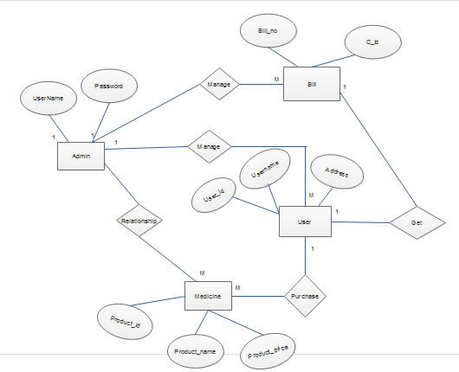

**Fig: 4.3. E-R diagram**

CLASS DIAGRAM:



**Fig: 4.4. Class diagram**

OBJECT DIAGRAM:

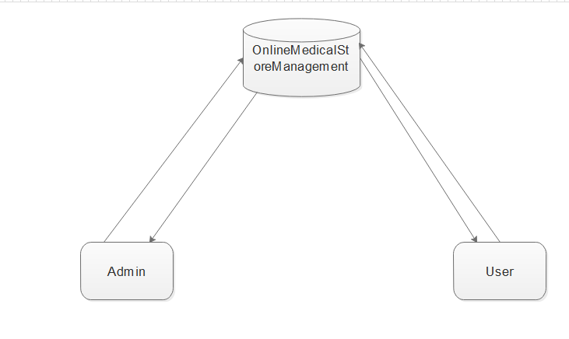

**Fig: 4.5. Object diagram**

COMPONENT DIAGRAM

Admin component:



**Fig: 4.6. Component diagram for admin**

User Component:



**Fig: 4.7. Component diagram for user**

DEPLOYMENT DIAGRAM



**Fig: 4.8. Deployment diagram**

SEQUENCE DIAGRAMS:

Admin sequence:



**Fig: 4.9. Sequence diagram for admin**

User sequence: 

**Fig: 4.10. Sequence diagram for user**

COLLABORATION DIAGRAMS

Admin collaboration:



**Fig: 4.11. Collaboration diagram for admin**

User collaboration:



**Fig: 4.12. Collaboration diagram for user**

ACTIVITY DIAGRAMS

Admin activity:



**Fig: 4.13. Activity diagram for admin**

User activity

**Fig: 4.14. Activity diagram for user**

DATA FLOW DIAGRAMS

Admin DFD:

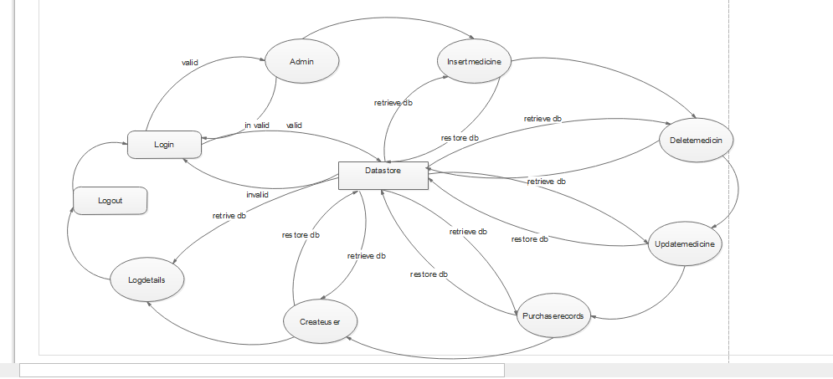

**Fig: 4.15. Data Flow Diagram for admin**

User DFD:

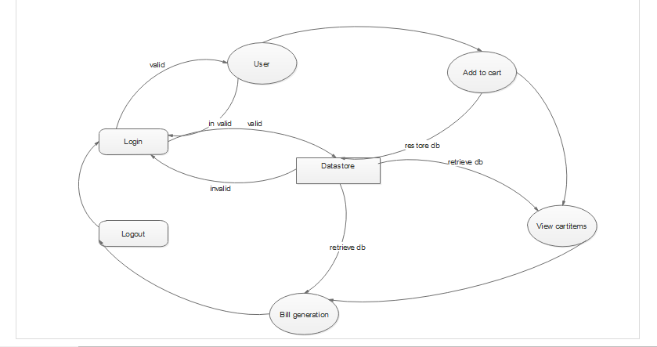

**Fig: 4.16. Data Flow Diagram for user**

**5. DATABASE DESIGN**

**Add to Cart Table:**

|  |  |  |  |
| --- | --- | --- | --- |
| **Field** | **Type** | **Null** | **Default** |
| ***Id*** | int(10) | No |  |
| UserName | varchar(20) | No |  |
| ProductName | varchar(20) | No |  |
| CompanyName | varchar(20) | No |  |
| ProductQuantity | Int(20) | No |  |
|  |  |  |  |
| Price | int(10) | No |  |

**Fig: 5.1. Add to Cart table**

**Insert MedicineTable:**

|  |  |  |  |
| --- | --- | --- | --- |
| **Field** | **Type** | **Null** | **Default** |
| ***Med _Id*** | int(100) | No |  |
| ProductName | char(20) | No |  |
| CompanyName | varchar(20) | No |  |
| ProductQuality | int(20) | No |  |
| ProductQuantity | int(20) | No |  |
| ProductPrice | Int(10) | No |  |
| ExpiryDate | date(10) | No |  |

**Fig: 5.2. Insert Medicine table**

**Login Tables:**

|  |  |  |  |
| --- | --- | --- | --- |
| **Field** | **Type** | **Null** | **Default** |
| ***log_id*** | int(11) | No |  |
| UserName | varchar(20) | No |  |
| PassWord | varchar(20) | No |  |

**Fig: 5.3. Login table**

**Product Details Tables:**

|  |  |  |  |
| --- | --- | --- | --- |
| **Field** | **Type** | **Null** | **Default** |
| product_id | int(11) | No |  |
| UserName | varchar(20) | No |  |
| ProductName | varchar(20) | No |  |
| ProductQuantity | int(10) | No |  |
| ProductPrice | int(10) | No |  |
|  |  |  |  |

**Fig: 5.4. Product Details table**

**Register Table:**

|  |  |  |  |
| --- | --- | --- | --- |
| **Field** | **Type** | **Null** | **Default** |
| id | int(10) | No |  |
| UserName | varchar(20) | No |  |
| NewPassword | varchar(20) | No |  |
| ReenterPassword | varchar(20) | No |  |
| Email | varchar(20) | No |  |
| ContactNumber | int(10) | No |  |
| Address | Varchar(100) | No |  |

**Fig: 5.5. Register table**

**6. TESTING**

The development of software systems involves of a serious of production activities where opportunities for injection of human feasibilities are enormous. .Errors may begin to occur at the very inception of the process where the objectives may be erroneously or imperfectly specified, as well as in later design and development stages. Because of human inability to perform and communicate with perfection, software development is accompanied by a quality assurance activity.

|  |  |  |
| --- | --- | --- |
| S.NO | Table name | Validation |
| 1. | Login | Only authenticated persons are allowed to login into their web pages, authentication provided by creating positions to admin and user by using some privileges. |
| 2. | Create User | First name and last name should contain minimum 10 letters, e-mail-id need both integers and alphabets, password should need both integer and alphabet and should be 15 word lengths. All fields have to fill compulsory. |
| 3. | Add Medicines | Medicine category is added and type of category to be added, Medicine category to be deleted in necessary conditions. |
|  |  |  |
|  |  |  |

**7. SCREENSHOTS**

**Home page:**

**Description:** This is Home page

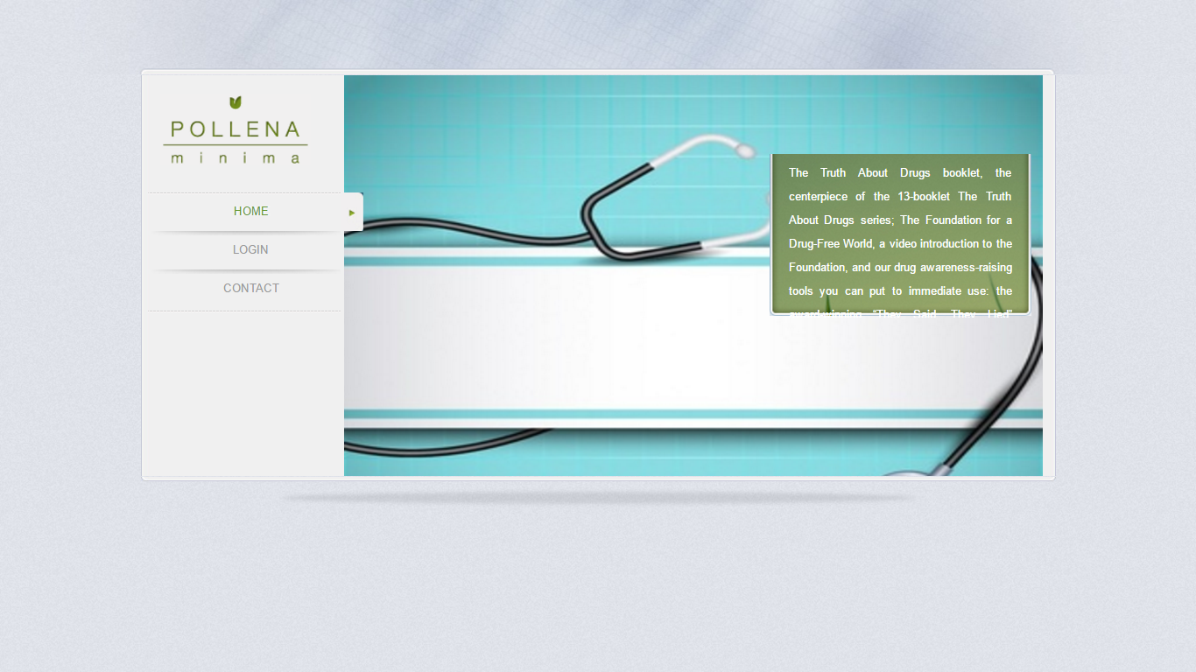**Fig: 8.1. Home page**

**Login page:**

**Description:** This is Login page

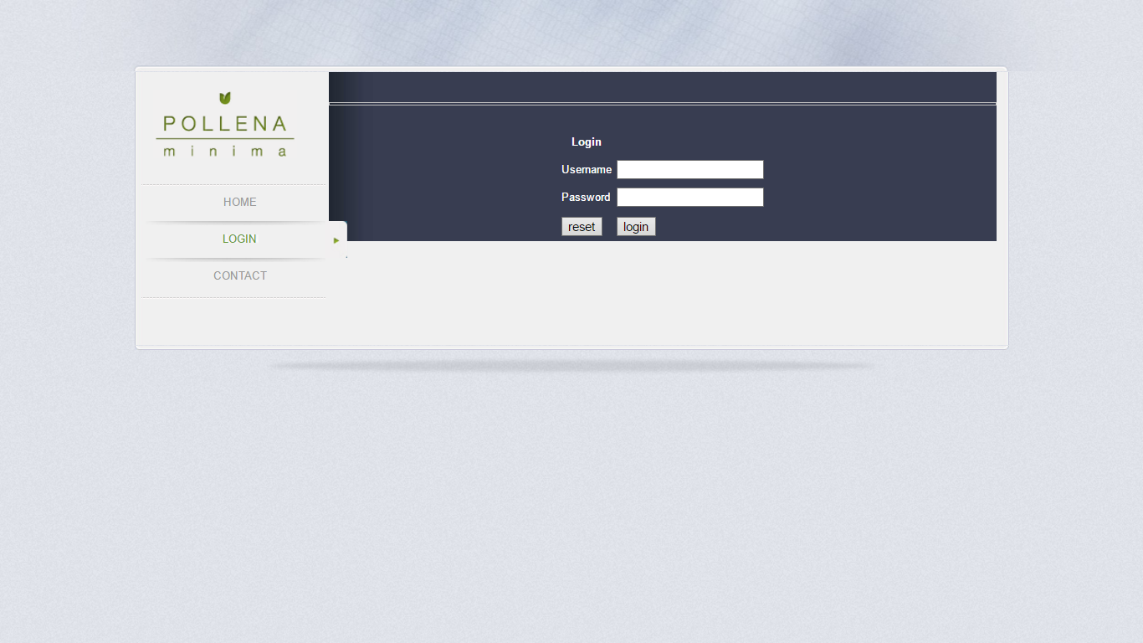**Fig: 8.2. Login page**

**Contact us page:**

**Description:** This is Contact us page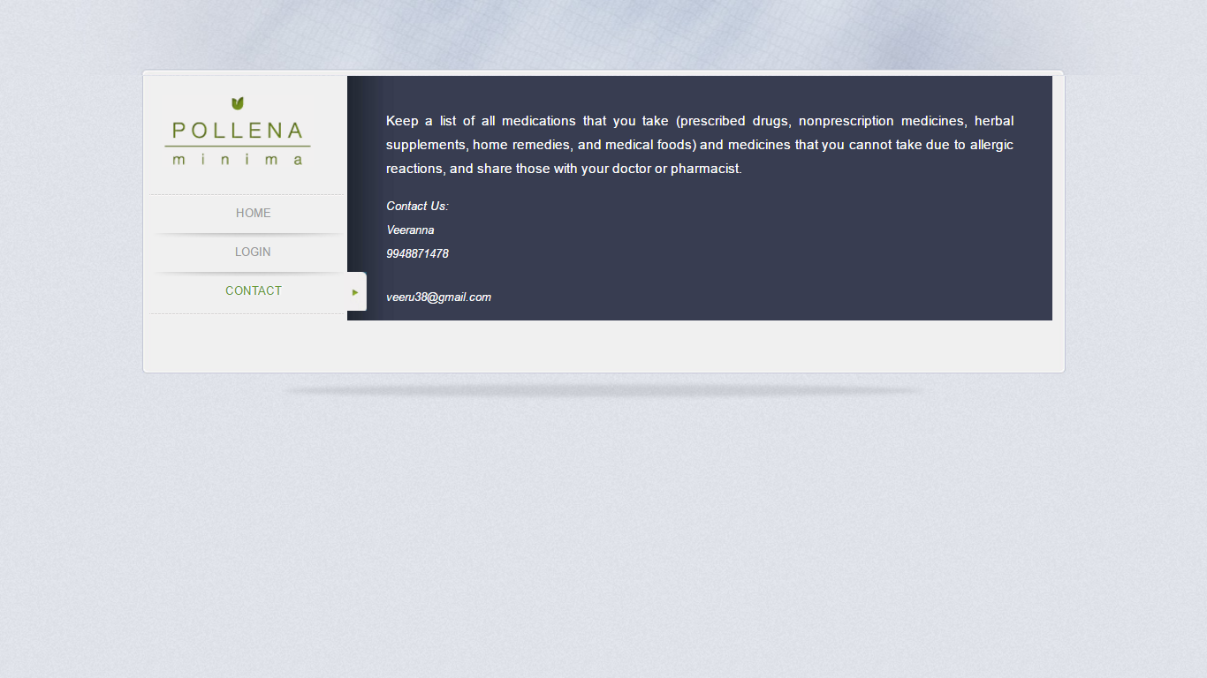

**Fig: 8.3. Contact us page**

**Admin page:**

**Description:** This is Admin page



**Fig: 8.4. Category page**

**Add Medicine page:**

**Description:** This is Add Medicine Page

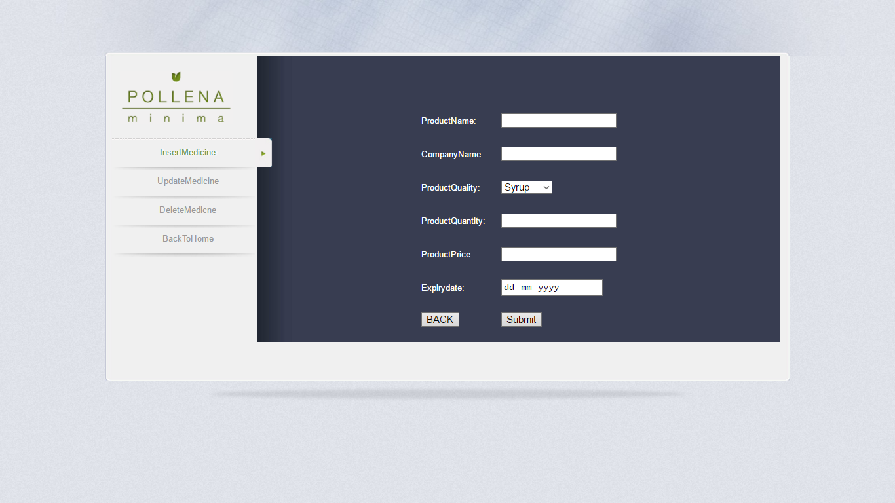

**Fig: 8.5. Add Medicine page**

**Update Medicine page:**

**Description:** This is Update Medicine Page

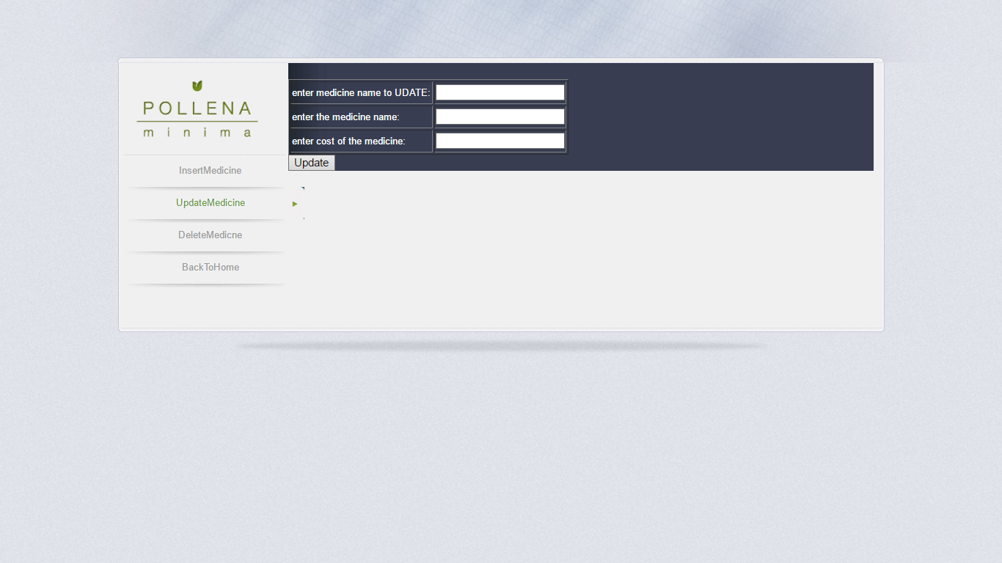

**Fig: 8.6. UpdateMedicine page**

**Delete Medicine page:**

**Description:** This is Delete Medicine Page

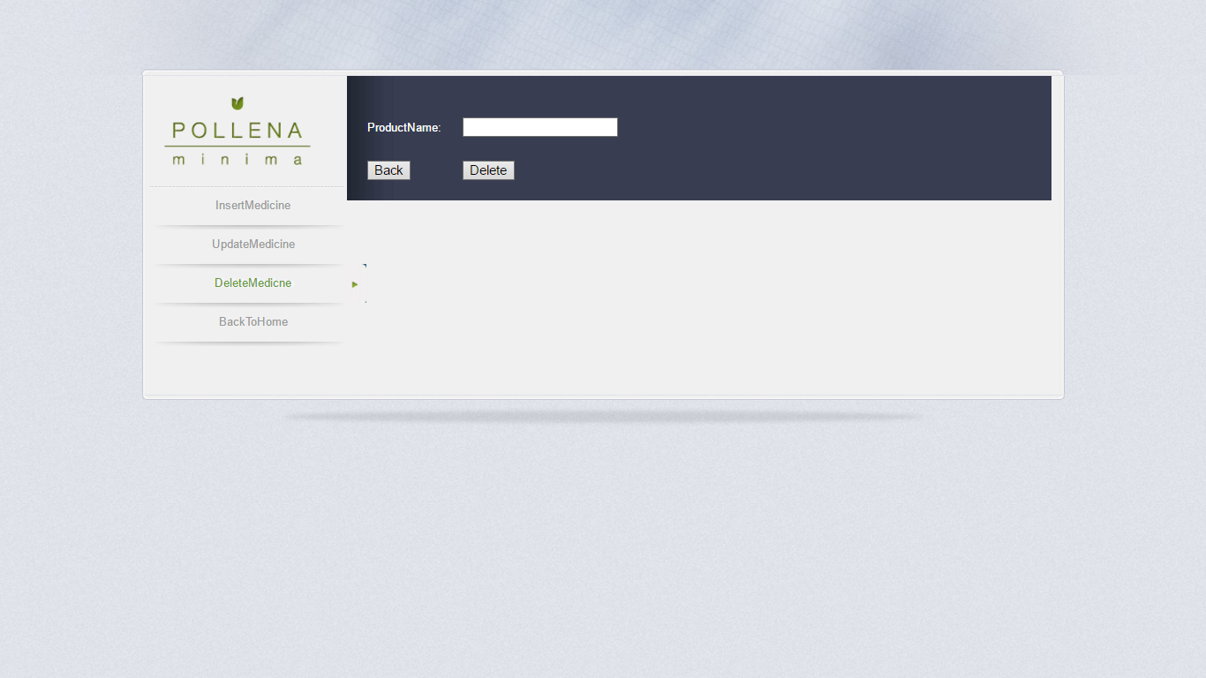

**Fig: 8.7. Book list page**

**Purchase records page:**

**Description:** This is Purchase records Page

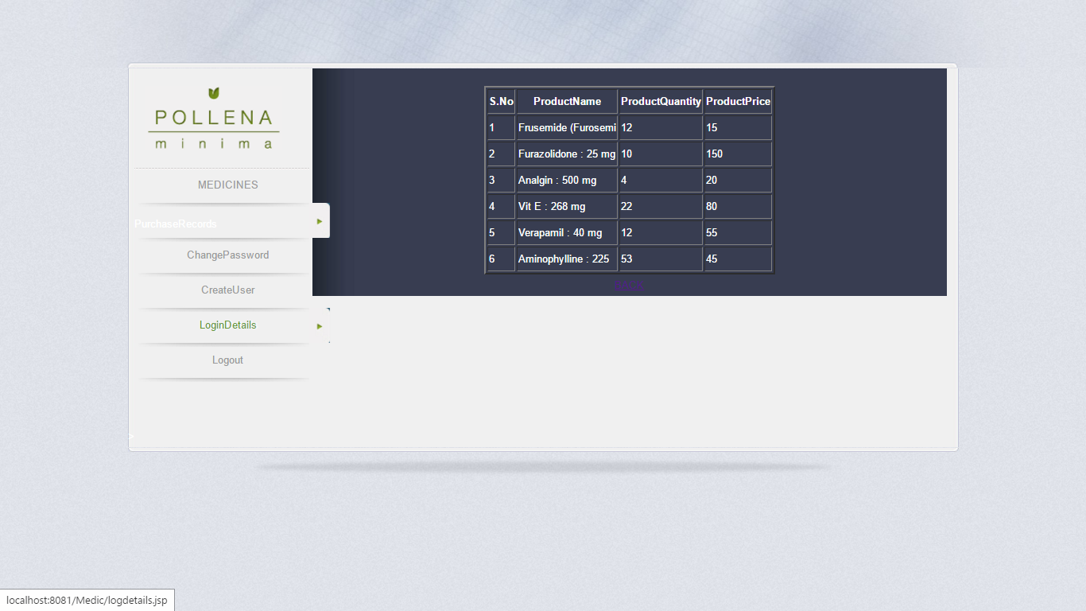

**Fig: 8.8. Purchase records page**

**Change Password page:**

**Description:** This is Change Password Page

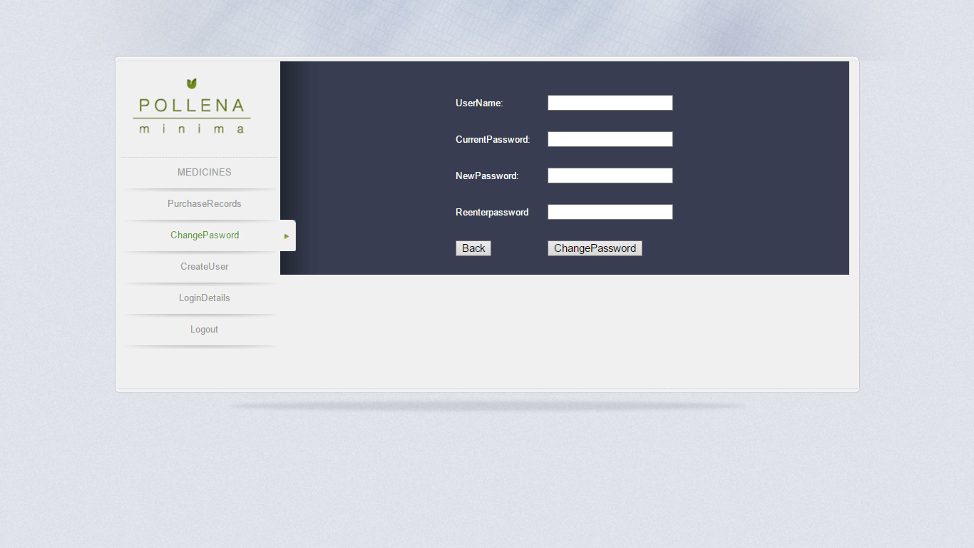

**Fig: 8.9. ChangePassword page**

**Create User page:**

**Description:** This is Create User page

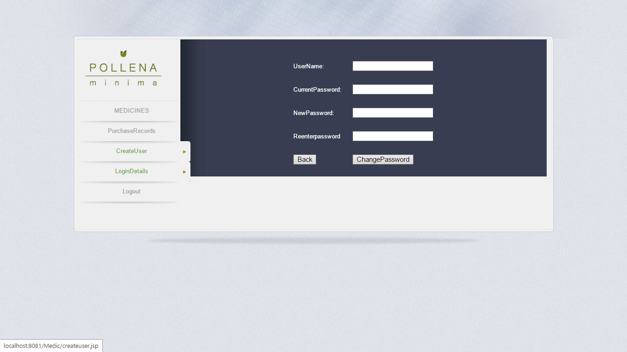

**Fig: 8.10. Create User page**

**Logindetails page:**

**Description:** This is Loginedetails page

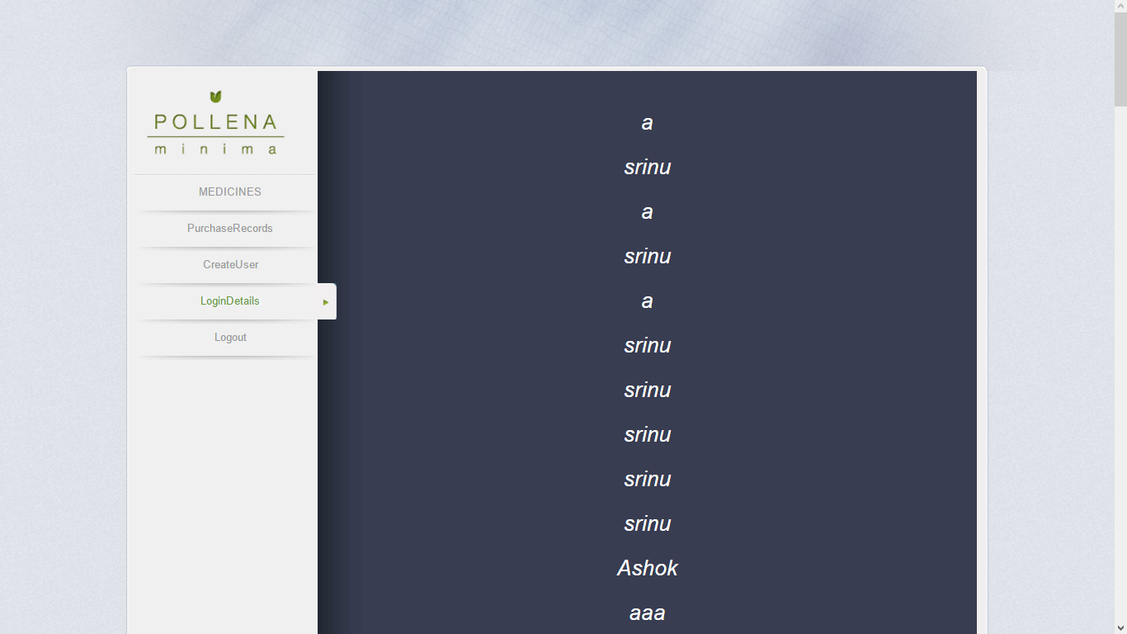

**Fig: 8.11. Login Details page**

**Add to cart page:**

**Description:** This is Add to Cart page

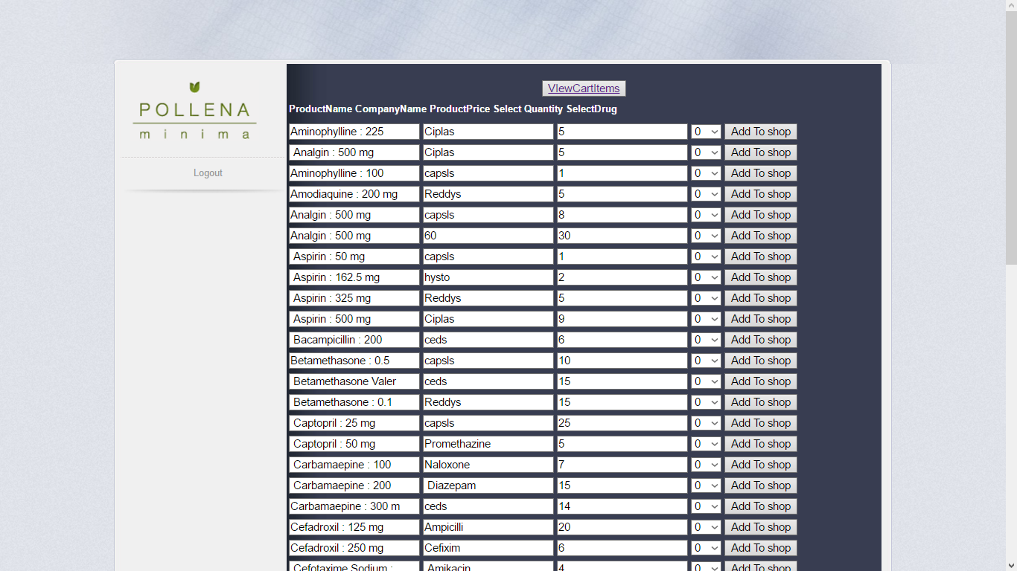

**Fig: 8.13. Add to cart page**

**View cart items page:**

**Description:** This is View cart items Page

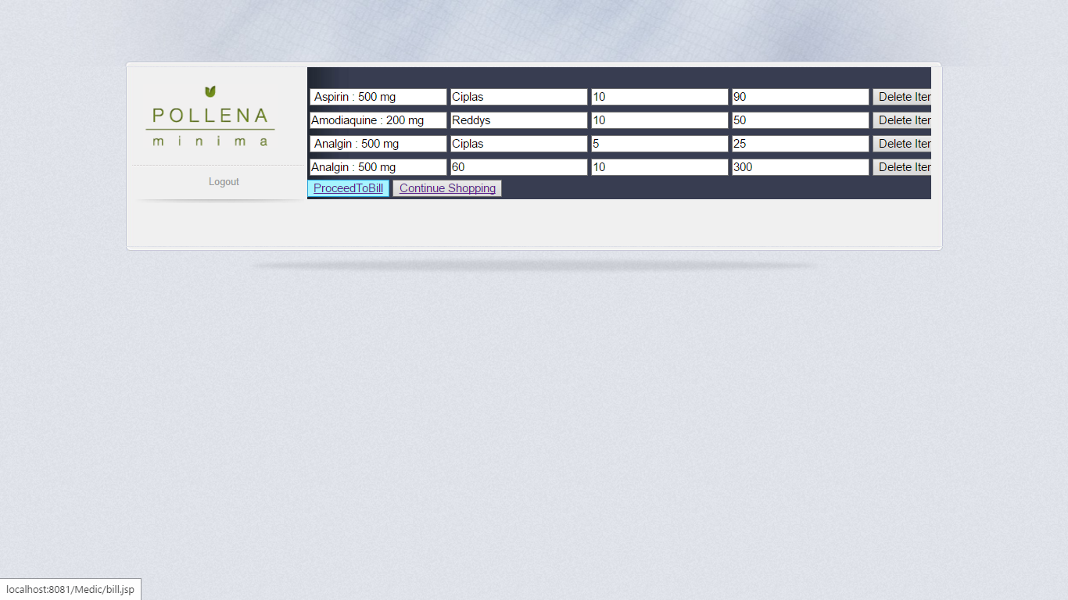

**Fig: 8.14. View cart items page**

**Bill page:**

**Description:** This is Bill Page

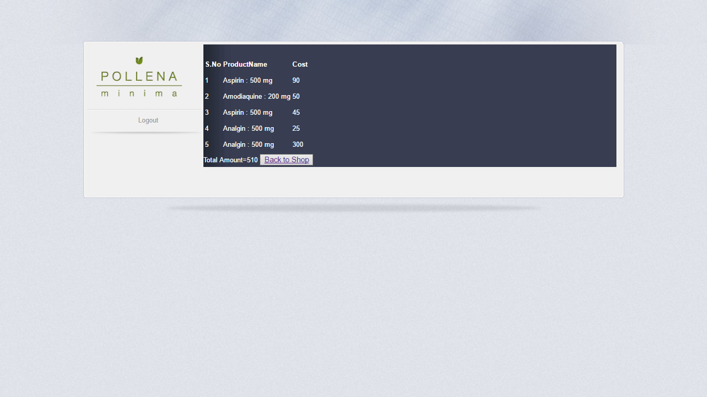

**Fig: 8.15. Bill page**

**9. CONCLUSION**

This project aims at creating an online ONLINE MEDICAL STORE MANAGEMENT. It allows only registered users to access search for the medicines. The administrator can approve or reject the users and he can add the medicines. The users can purchase medicines based on username. So that we can reduce the time of users by implementing this system.

**9.1. FUTURE ENHANCEMENT:**

* To provide users to purchase medicine online.
* To add/delete user,manage their accounts.
* To reduce user’s searching time.
* To provide great discount over purchasing.
* To provide wide collection of book ranges.
* To provide user friendly environment.
* To provide facility of user feedback.
* To provide sms facility to automatic acknowledgement user.

**10. REFERENCES**

**1.** <http://www.google.com/>

**2.** <http://www.apache.org/>

**3.** <http://www.mysql.com/>

**4.** <http://www.wikipedia.org/>

**5.** [http://www.tutorialpoint.com/jsp/](http://www.tutorialpoint.com/php/)

**6.** <http://www.w3schools.com/jsp/>

**BIBLIOGRAPHY:**

1. Complete Reference JAVA by Herbert Schildt

2. Servlets by O’reilly.

3. WebTechnology by M.K.Roy.

4. JavaServer Pages by Hans Bergsten